COMPUTER COMMUNICATION
UNIT 3

Line Coding
A line code is the code used for data transmission of a digital signal over a transmission line. This process of coding is chosen so as to avoid overlap and distortion of signal such as inter-symbol interference.

Types of Line Coding
There are 3 types of Line Coding
- Unipolar
- Polar
- Bi-polar

Unipolar Signaling
Unipolar signaling is also called as On-Off Keying or simply OOK.
The presence of pulse represents a 1 and the absence of pulse represents a 0.
There are two variations in Unipolar signaling −
- Non Return to Zero NRZNRZ
- Return to Zero RZRZ

Unipolar Non-Return to Zero NRZNRZ
In this type of unipolar signaling, a High in data is represented by a positive pulse called as Mark, which has a duration T₀ equal to the symbol bit duration. A Low in data input has no pulse.
The following figure clearly depicts this.
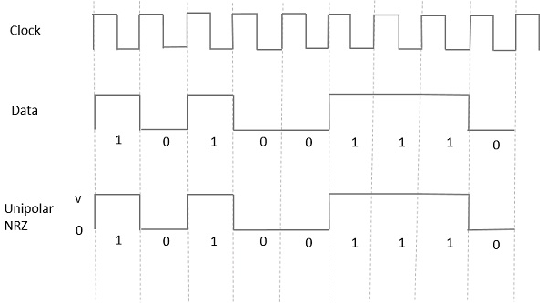
Advantages
The advantages of Unipolar NRZ are −
- It is simple.
- A lesser bandwidth is required.
Disadvantages
The disadvantages of Unipolar NRZ are −
- No error correction done.
- Presence of low frequency components may cause the signal droop.
- No clock is present.
- Loss of synchronization is likely to occur (especially for long strings of 1s and 0s).

Unipolar Return to Zero RZRZ
In this type of unipolar signaling, a High in data, though represented by a Mark pulse, its duration T₀ is less than the symbol bit duration. Half of the bit duration remains high but it immediately returns to zero and shows the absence of pulse during the remaining half of the bit duration.
It is clearly understood with the help of the following figure.
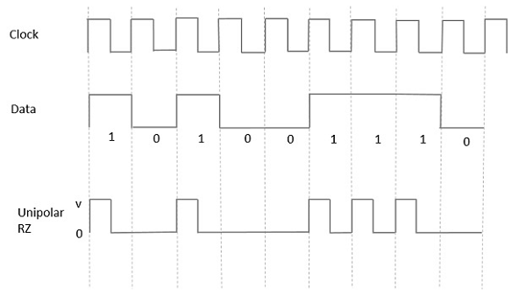
Advantages
The advantages of Unipolar RZ are −
- It is simple.
- The spectral line present at the symbol rate can be used as a clock.
Disadvantages
The disadvantages of Unipolar RZ are −
- No error correction.
- Occupies twice the bandwidth as unipolar NRZ.
- The signal droop is caused at the places where signal is non-zero at 0 Hz.

Polar Signaling
There are two methods of Polar Signaling. They are −
- Polar NRZ
- Polar RZ

Polar NRZ
In this type of Polar signaling, a High in data is represented by a positive pulse, while a Low in data is represented by a negative pulse. The following figure depicts this well.
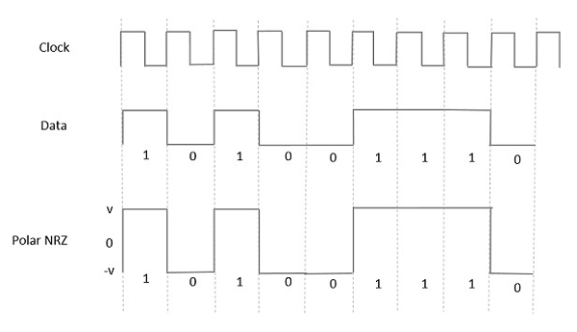
Advantages
The advantages of Polar NRZ are −
- It is simple.
- No low-frequency components are present.
Disadvantages
The disadvantages of Polar NRZ are −
- No error correction.
- No clock is present.
- The signal droop is caused at the places where the signal is non-zero at 0 Hz.

Polar RZ
In this type of Polar signaling, a High in data, though represented by a Mark pulse, its duration T₀ is less than the symbol bit duration. Half of the bit duration remains high but it immediately returns to zero and shows the absence of pulse during the remaining half of the bit duration.
However, for a Low input, a negative pulse represents the data, and the zero level remains same for the other half of the bit duration. The following figure depicts this clearly.
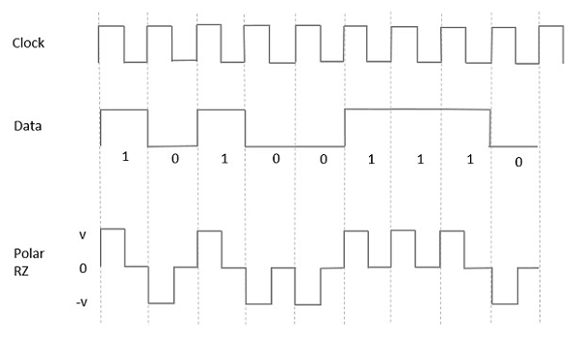
Advantages
The advantages of Polar RZ are −
- It is simple.
- No low-frequency components are present.
Disadvantages
The disadvantages of Polar RZ are −
- No error correction.
- No clock is present.
- Occupies twice the bandwidth of Polar NRZ.
- The signal droop is caused at places where the signal is non-zero at 0 Hz.

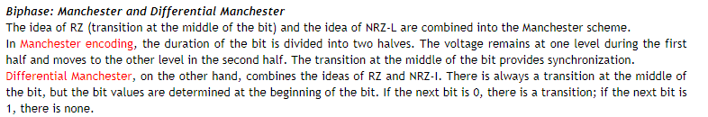
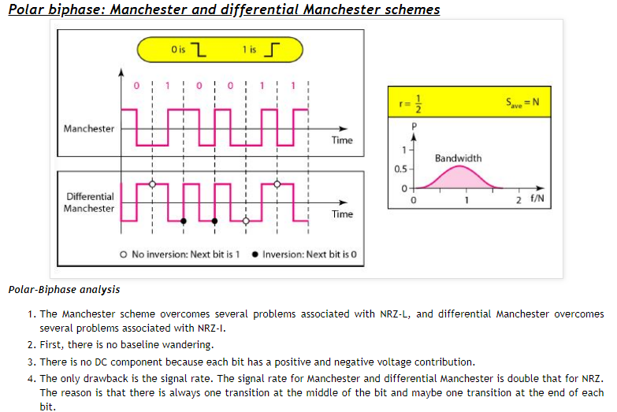

Bipolar Signaling
This is an encoding technique which has three voltage levels namely +, - and 0. Such a signal is called as duo-binary signal.
An example of this type is Alternate Mark Inversion AMIAMI. For a 1, the voltage level gets a transition from + to – or from – to +, having alternate 1s to be of equal polarity. A 0 will have a zero voltage level.
Even in this method, we have two types.
- Bipolar NRZ
- Bipolar RZ
From the models so far discussed, we have learnt the difference between NRZ and RZ. It just goes in the same way here too. The following figure clearly depicts this.
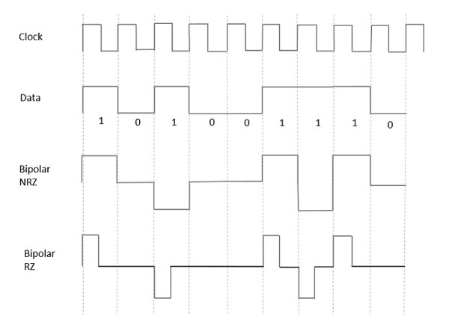
The above figure has both the Bipolar NRZ and RZ waveforms. The pulse duration and symbol bit duration are equal in NRZ type, while the pulse duration is half of the symbol bit duration in RZ type.

Advantages
Following are the advantages −
- It is simple.
- No low-frequency components are present.
- Occupies low bandwidth than unipolar and polar NRZ schemes.
- This technique is suitable for transmission over AC coupled lines, as signal drooping doesn’t occur here.
- A single error detection capability is present in this.

Disadvantages
Following are the disadvantages −
- No clock is present.
- Long strings of data causes loss of synchronization.

Digital to Analog Conversion

Digital Signal – A digital signal is a signal that represents data as a sequence of discrete values; at any given time it can only take on one of a finite number of values.
Analog Signal – An analog signal is any continuous signal for which the time varying feature of the signal is a representation of some other time varying quantity i.e., analogous to another time varying signal.

The following techniques can be used for Digital to Analog Conversion:
Amplitude Shift keying
In amplitude shift keying, the amplitude of the carrier signal is varied to create signal elements. Both frequency and phase remain constant while the amplitude changes.

Binary ASK (BASK)
Although we can have several levels (kinds) of signal elements, each with a different amplitude, ASK is normally implemented using only two levels. This is referred to as binary amplitude shift keying or on-off keying (OOK). The peak amplitude of one signal level is 0; the other is the same as the amplitude of the carrier frequency. gives a conceptual view of binary ASK.

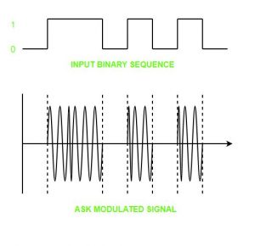
Although the carrier signal is only one simple sine wave, the process of modulation produces a
nonperiodic composite signal. This signal, as was discussed in Chapter 3, has a continuous set of frequencies. As we expect, the bandwidth is proportional to the signal rate (baud rate). However, there is normally another factor involved, called d, which depends on the modulation and filtering process. The value of d is between 0 and 1. This means that the bandwidth can be expressed as shown, where 5 is the signal rate and the B is the bandwidth.

B =(1 +d) x S
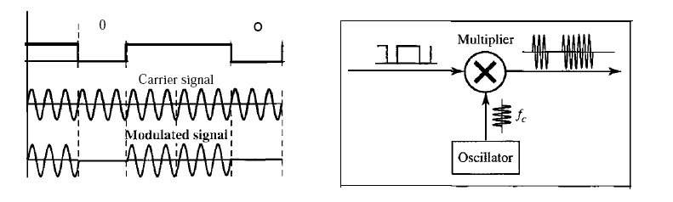

Advantages of amplitude shift Keying –
It can be used to transmit digital data over optical fiber.
The receiver and transmitter have a simple design which also makes it comparatively inexpensive.
It uses lesser bandwidth as compared to FSK thus it offers high bandwidth efficiency.
Disadvantages of amplitude shift Keying –
It is susceptible to noise interference and entire transmissions could be lost due to this.
It has lower power efficiency.
Frequency Shift Keying

In frequency shift keying, the frequency of the carrier signal is varied to represent data. The frequency of the modulated signal is constant for the duration of one signal element, but changes for the next signal element if the data element changes. Both peak amplitude and phase remain constant for all signal elements.

One way to think about binary FSK (or BFSK) is to consider two carrier frequencies. In Figure 5.6, we have selected two carrier frequencies, f1 and12. We use the first carrier if the data element is 0; we use the second if the data element is 1. However, note that this is an unrealistic example used only for demonstration purposes. Normally the carrier frequencies are very high, and the difference between them is very small. Again the carrier signals are only simple sine waves, but the modulation creates a non periodic composite signal with continuous frequencies. We can think of FSK as two ASK signals, each with its own carrier frequency Cil or F2). If the difference between the two frequencies is 2DELf, then the required bandwidth is
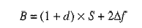
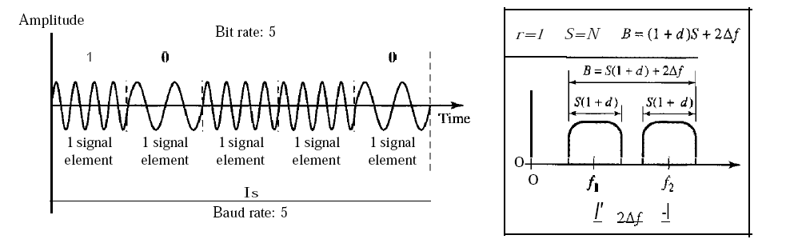
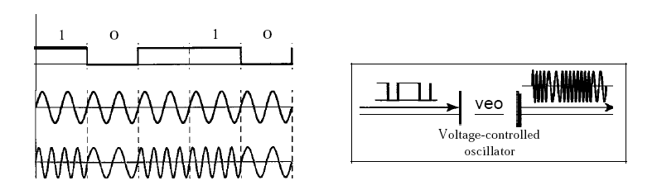
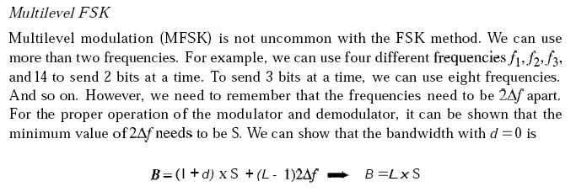
Advantages of frequency shift Keying –
- Frequency shift keying modulated signal can help avoid the noise problems beset by ASK.
- It has lower chances of an error.
- It provides high signal to noise ratio.
- The transmitter and receiver implementations are simple for low data rate application.
Disadvantages of frequency shift Keying –
- It uses larger bandwidth as compared to ASK thus it offers less bandwidth efficiency.
- It has lower power efficiency.

Phase Shift Keying
In phase shift keying, the phase of the carrier is varied to represent two or more different signal elements. Both peak amplitude and frequency remain constant as the phase changes. Today, PSK is more common than ASK or FSK. However, we will see Sh0l1ly that QAM, which combines ASK and PSK, is the dominant method of digitalto-analog modulation.

The simplest PSK is binary PSK, in which we have only two signal elements, one with a phase of 0°, and the other with a phase of 180°.. Binary PSK is as simple as binary ASK with one big advantage-it is less

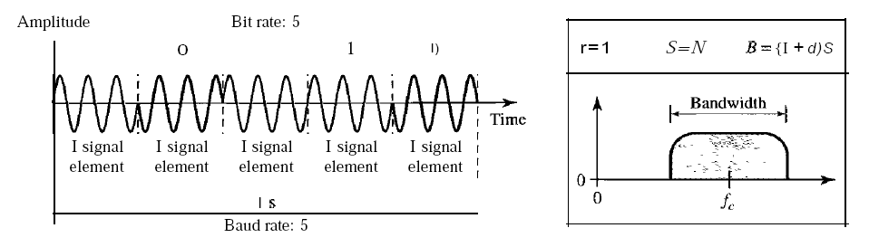
susceptible to noise. In ASK, the criterion for bit detection is the amplitude of the signal; in PSK, it is the phase. Noise can change the amplitude easier than it can change the phase. In other words, PSK is less susceptible to noise than ASK. PSK is superior to FSK because we do not need two carrier signals. The bandwidth is the same as that for binary ASK, but less than that for BFSK. No bandwidth is wasted for separating two carrier signals.

Quadrature PSK (QPSK)

The simplicity of BPSK enticed designers to use 2 bits at a time in each signal element, thereby decreasing the baud rate and eventually the required bandwidth. The scheme is called quadrature PSK or QPSK because it uses two separate BPSK modulations; one is in-phase, the other quadrature (out-of-phase). The incoming bits are first passed through a serial-to-parallel conversion that sends one bit to one modulator and the next bit to the other modulator. If the duration of each bit in the incoming signal is T, the duration of each bit sent to the corresponding BPSK signal is 2T. This means that the bit to each BPSK signal has one-half the frequency of the original signal.

Advantages of phase shift Keying –
- It is a more power efficient modulation technique as compared to ASK and FSK.
- It has lower chances of an error.
- It allows data to be carried along a communication signal much more efficiently as compared to FSK.
Disadvantages of phase shift Keying –
- It offers low bandwidth efficiency.
- The detection and recovery algorithms of binary data is very complex.
- It is a non coherent reference signal.

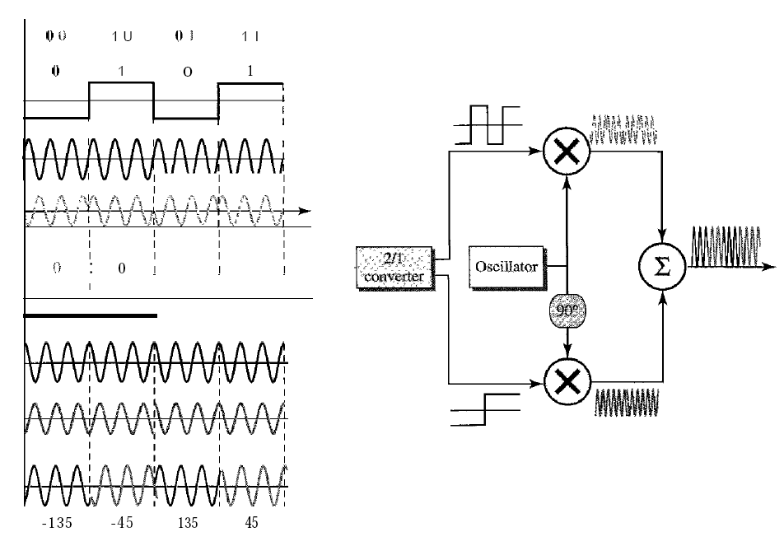
ANALOG-TO-DIGITAL CONVERSION
Modulation is the process of varying one or more parameters of a carrier signal in accordance with the instantaneous values of the message signal.
The message signal is the signal which is being transmitted for communication and the carrier signal is a high frequency signal which has no data, but is used for long distance transmission.

Pulse Code Modulation (PCM)

The most common technique to change an analog signal to digital data (digitization) is called pulse code modulation (PCM)
1. The analog signal is sampled.
2. The sampled signal is quantized.
3. The quantized values are encoded as streams of bits.
The transmitter section of a Pulse Code Modulator circuit consists of Sampling, Quantizing and Encoding, which are performed in the analog-to-digital converter section. The low pass filter prior to sampling prevents aliasing of the message signal.

Sampler
This is the technique which helps to collect the sample data at instantaneous values of message signal, so as to reconstruct the original signal. The sampling rate must be greater than twice the highest frequency component W of the message signal, in accordance with the sampling theorem.
The sampling process is sometimes referred to as pulse amplitude modulation (PAM). We need to remember, however, that the result is still an analog signal with nonintegral values

Quantizer
Quantizing is a process of reducing the excessive bits and confining the data. The sampled output when given to Quantizer, reduces the redundant bits and compresses the value.
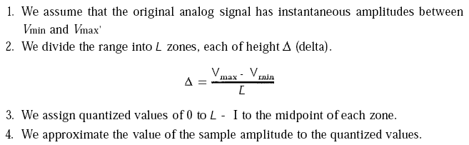

Encoder
The digitization of analog signal is done by the encoder. It designates each quantized level by a binary code. The sampling done here is the sample-and-hold process. These three sections LPF,Sampler,andQuantizerLPF,Sampler,andQuantizer will act as an analog to digital converter. Encoding minimizes the bandwidth used.

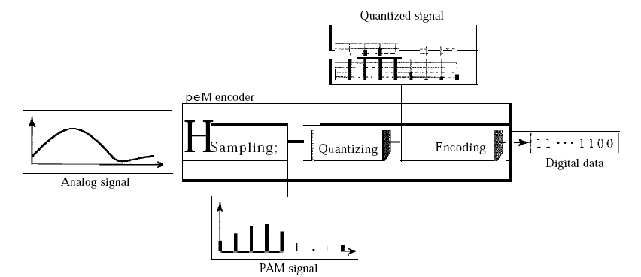
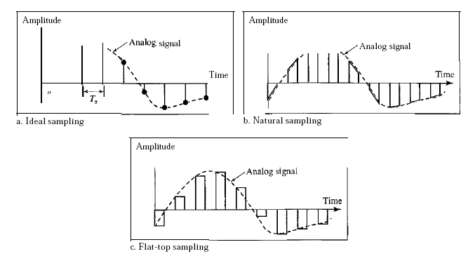
SAMPLING METHODS
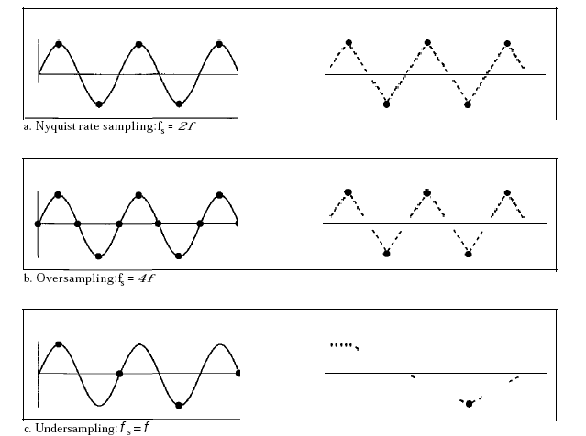
Recovery ofa sampled sine wave for different sampling rates
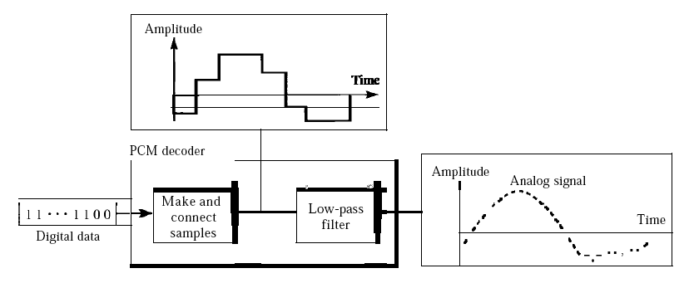
Components ofa PCM decoder
Delta Modulation (DM)
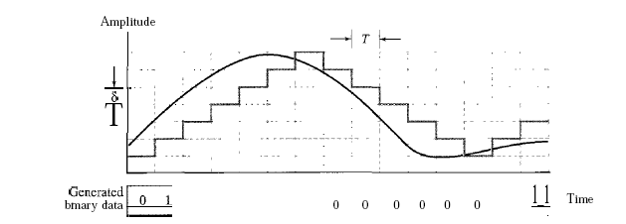
PCM is a very complex technique. Other techniques have been developed to reduce the complexity of PCM. The simplest is delta modulation. PCM finds the value of the signal amplitude for each sample; DM finds the change from the previous sample. Note that there are no code words here; bits are sent one after another.
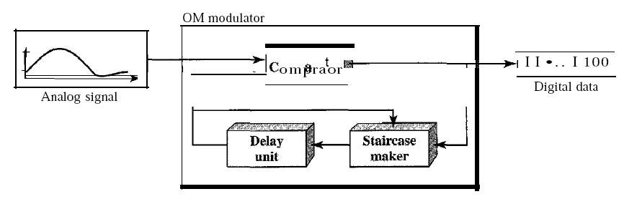
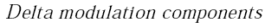
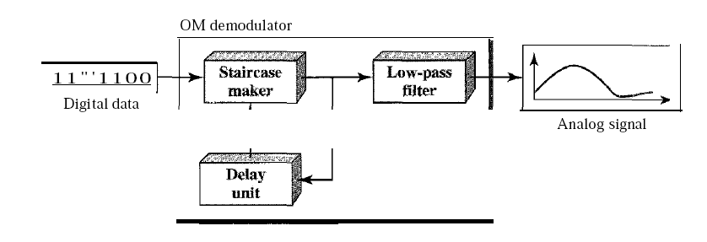
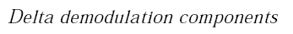
Modulator
The modulator is used at the sender site to create a stream of bits from an analog signal. The process records the small positive or negative changes, called delta O. If the delta is positive, the process records a I; if it is negative, the process records a O. However, the process needs a base against which the analog signal is compared. The modulator builds a second signal that resembles a staircase. Finding the change is then reduced to comparing the input signal with the gradually made staircase signal.. If the amplitude of the analog signal is larger, the next bit in the digital data is 1; otherwise, it is O. The output of the comparator, however, also makes the staircase itself. If the next bit is I, the staircase maker moves the last point of the staircase signal 0 up; it the next bit is 0, it moves it 0 down. Note that we need a delay unit to hold the staircase function for a period between two comparisons.
Demodulator
The demodulator takes the digital data and, using the staircase maker and the delay unit, creates the analog signal. The created analog signal, however, needs to pass through a low-pass filter for smoothing.

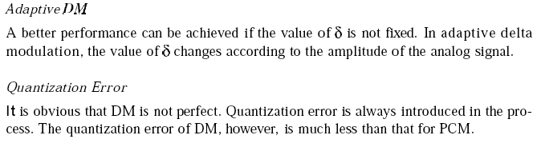

MULTIPLEXING
Frequency-Division Multiplexing

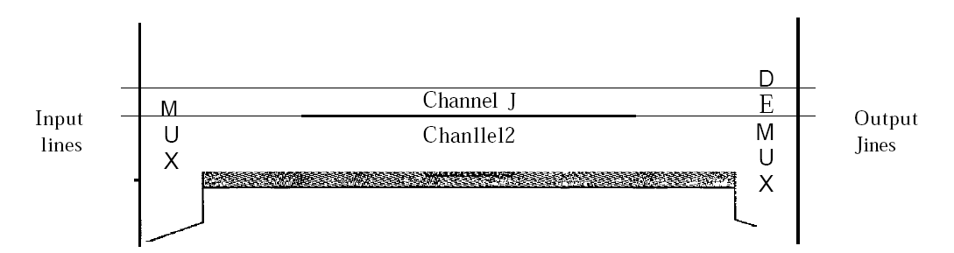
MODULATOR
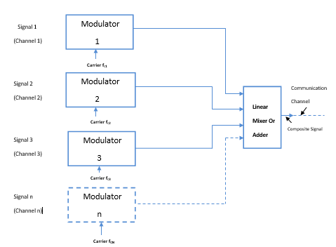

DEMODULATOR
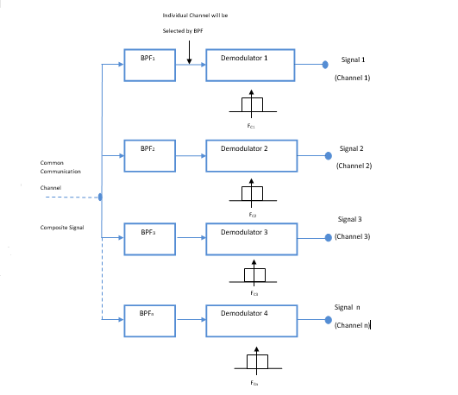
Frequency-division multiplexing (FDM) is an analog technique that can be applied when the bandwidth of a link (in hertz) is greater than the combined bandwidths of the signals to be transmitted. In FOM, signals generated by each sending device modulate different carrier frequencies. These modulated signals are then combined into a single composite signal that can be transported by the link. Carrier frequencies are separated by sufficient bandwidth to accommodate the modulated signal. These bandwidth ranges are the channels through which the various signals travel. Channels can be separated by strips of unused bandwidth-guard bands-to prevent signals from overlapping. In addition, carrier frequencies must not interfere with the original data frequencies.
The transmission path is divided into three parts, each representing a channel that carries one transmission. We consider FDM to be an analog multiplexing technique; however, this does not mean that FDM cannot be used to combine sources sending digital signals. A digital signal can be converted to an analog signal before FDM is used to multiplex them.

Guard Band
Frequency overlap is a serious issue when it comes to frequency division multiplexing and it must be completely avoided. Two frequency ranges can be separated by using some narrow frequency ranges called guard bands. The guard bands avoid signal interference and enhance the quality of communication.

Multiplexing Process
Figure 6.4 is a conceptual illustration of the multiplexing process. Each source generates a signal of a similar frequency range. Inside the multiplexer, these similar signals modulates different carrier frequencies (/1,12, and h). The resulting modulated signals are then combined into a single composite signal that is sent out over a media link that has enough bandwidth to accommodate it
Demultiplexing Process
The demultiplexer uses a series of filters to decompose the multiplexed signal into its constituent component signals. The individual signals are then passed to a demodulator that separates them from their carriers and passes them

Advantages of FDM:
1. A large number of signals (channels) can be transmitted simultaneously.
2. FDM does not need synchronization between its transmitter and receiver for proper operation.
3. Demodulation of FDM is easy.
4. Due to slow narrow band fading only a single channel gets affected.

Disadvantages of FDM:

1. The communication channel must have a very large bandwidth.

2. Intermodulation distortion takes place.

3. Large number of modulators and filters are required.

4. FDM suffers from the problem of crosstalk.

5. All the FDM channels get affected due to wideband fading.

Applications of FDM

1. FDM is used for FM & AM radio broadcasting. Each AM and FM radio station uses a different carrier frequency. In AM broadcasting, these frequencies use a special band from 530 to 1700 KHz. All these signals/frequencies are multiplexed and are transmitted in air. A receiver receives all these signals but tunes only one which is required. Similarly FM broadcasting uses a bandwidth of 88 to 108 MHz

2. FDM is used in television broadcasting.

3. First generation cellular telephone also uses FDM.

Problem:

Five channels, each with a lOa-kHz bandwidth, are to be multiplexed together. What is the minimum bandwidth of the link if there is a need for a guard band of 10kHz between the channels to prevent interference?

Solution

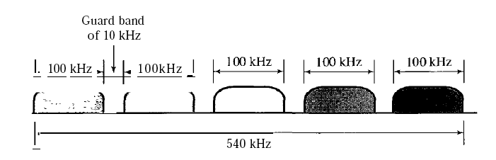

For five channels, we need at least four guard bands. This means that the required bandwidth is at
least 5 x 100 + 4 x 10 =540 kHz

Wavelength-Division Multiplexing

Wavelength-division multiplexing (WDM) is designed to use the high-data-rate capability of fiber-optic cable. The optical fiber data rate is higher than the data rate of metallic transmission cable. Using a fiber-optic cable for one single line wastes the available bandwidth. Multiplexing allows us to combine several lines into one. WDM is conceptually the same as FDM, except that the multiplexing and demultiplexing involve optical signals transmitted through fiber-optic channels. The idea is the same: We are combining different signals of different frequencies. The difference is that the frequencies are very high.

Although WDM technology is very complex, the basic idea is very simple. We want to combine multiple light sources into one single light at the multiplexer and do the reverse at the demultiplexer. The combining and splitting of light sources are easily handled by a prism. Recall from basic physics that a prism bends a beam of light based on the angle of incidence and the frequency. Using this technique, a multiplexer can be made to combine several input beams of light, each containing a narrow band of frequencies, into one output beam of a wider band of frequencies. A demultiplexer can also be made to reverse the process.

One application of WDM is the SONET
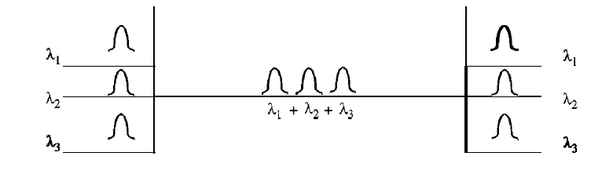
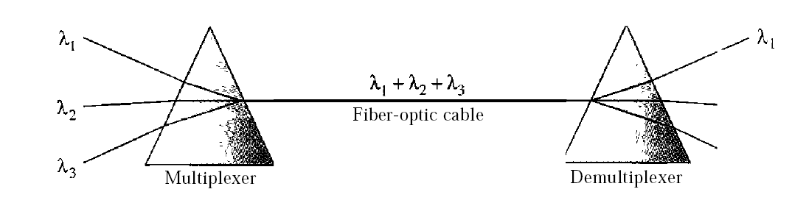
Time-Division Multiplexing

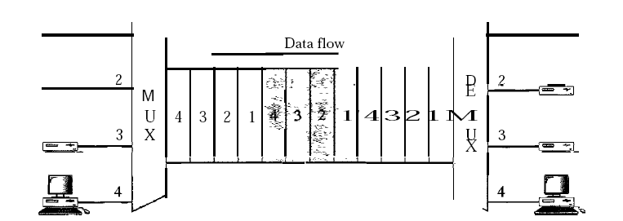

Types of TDM
1. Synchronous TDM
2. Asynchronous TDM

Synchronous TDM (STDM)
1. In synchronous TDM, each device is given same time slot to transmit the data over the link, irrespective of the fact that the device has any data to transmit or not. Hence the name Synchronous TDM. Synchronous TDM requires that the total speed of various input lines should not exceed the capacity of path.
2. Each device places its data onto the link when its time slot arrives i.e. each device is given the possession of line turn by turn.
3. If any device does not have data to send then its time slot remains empty.
4. The various time slots are organized into frames and each frame consists of one or more time slots dedicated to each sending device.
5. If there are n sending devices, there will be n slots in frame i.e. one slot for each device.
6. As show in fig, there are 3 input devices, so there are 3 slots in each frame.

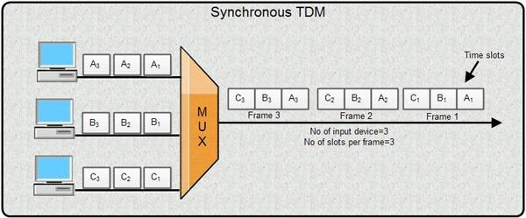

Multiplexing Process in STDM
1. In STDM every device is given the opportunity to transmit a specific amount of data onto the link.
2. Each device gets its turn in fixed order and for fixed amount of time. This process is known as interleaving.
3. We can say that the operation of STDM is similar to that of a fast interleaved switch. The switch opens in front of a device; the device gets a chance to place the data onto the link.
4. Such an interleaving may be done on the basis of a hit, a byte or by any other data unit.
5. In STDM, the interleaved units are of same size i.e. if one device sends a byte, other will also send a byte and so on.
6. As shown in the fig. interleaving is done by a character (one byte). Each frame consists of four slots as there are four input devices. The slots of some devices go empty if they do not have any data to send.
7. At the receiver, demultiplexer decomposes each frame by extracting each character in turn. As a character is removed from frame, it is passed to the appropriate receiving device.
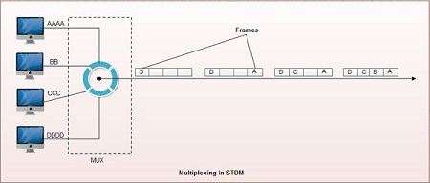

Disadvantages of Synchronous TDM
1. The channel capacity cannot be fully utilized. Some of the slots go empty in certain frames. As shown in fig only first two frames are completely filled. The last three frames have 6 empty slot. It means out of 20 slots in all, 6 slots are empty. This wastes the l/4th capacity of links.
2. The capacity of single communication line that is used to carry the various transmission should be greater than the total speed of input lines.

Asynchronous TDM
1. It is also known as statistical time division multiplexing.
2. Asynchronous TDM is called so because is this type of multiplexing, time slots are not fixed i.e. the slots are flexible.
3. Here, the total speed of input lines can be greater than the capacity of the path.
4. In synchronous TDM, if we have n input lines then there are n slots in one frame. But in asynchronous it is not so.
5. In asynchronous TDM, if we have n input lines then the frame contains not more than m slots, with m less than n (m < n).
6. In asynchronous TDM, the number of time slots in a frame is based on a statistical analysis of number of input lines.
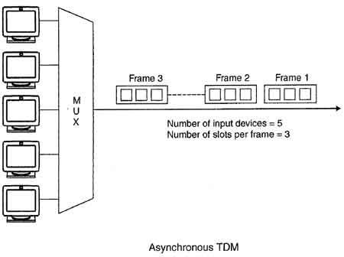
7. In this system slots are not predefined, the slots are allocated to any of the device that has data to send.
8. The multiplexer scans the various input lines, accepts the data from the lines that have data to send, fills the frame and then sends the frame across the link.
9. If there are not enough data to fill all the slots in a frame, then the frames are transmitted partially filled.
10. Asynchronous Time Division Multiplexing is depicted in fig. Here we have five input lines and three slots per frame.
11. In Case 1, only three out of five input lines place data onto the link i.e. number of input lines and number of slots per frame are same.
12. In Case 2, four out of five input lines are active. Here number of input line is one more than the number of slots per frame.
13. In Case 3, all five input lines are active.
In all these cases, multiplexer scans the various lines in order and fills the frames and transmits them across the channel.
The distribution of various slots in the frames is not symmetrical. In case 2, device 1 occupies first slot in first frame, second slot in second frame and third slot in third frame.

Advantages of TDM :
1. Full available channel bandwidth can be utilized for each channel.
2. lntermodulation distortion is absent.
3. TDM circuitry is not very complex.
4. The problem of crosstalk is not severe.

Disadvantages of TDM :
1. Synchronization is essential for proper operation.
2. Due to slow narrowband fading, all the TDM channels may get wiped out.

Guided Media
Types Of Guided media:

Twisted pair:
- Co-axial cable
- Optical fibre cable

Twisted pair:

Twisted pair is a physical media made up of a pair of cables twisted with each other. A twisted pair cable is cheap as compared to other transmission media. Installation of the twisted pair cable is easy, and it is a lightweight cable. The frequency range for twisted pair cable is from 0 to 3.5KHz.
A twisted pair consists of two insulated copper wires arranged in a regular spiral pattern.
The degree of reduction in noise interference is determined by the number of turns per foot. Increasing the number of turns per foot decreases noise interference.

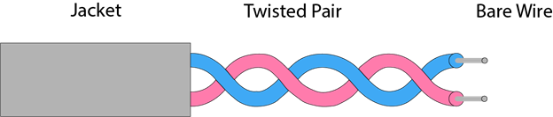

Types of Twisted pair:

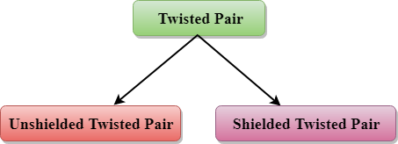

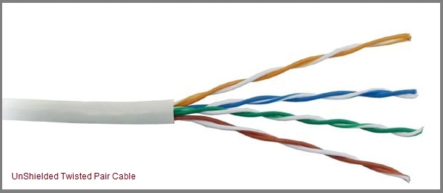

Unshielded Twisted Pair:
An unshielded twisted pair is widely used in telecommunication. Following are the categories of the unshielded twisted pair cable:
- Category 1: Category 1 is used for telephone lines that have low-speed data.
- Category 2: It can support upto 4Mbps.
- Category 3: It can support upto 16Mbps.
- Category 4: It can support upto 20Mbps. Therefore, it can be used for long-distance communication.
- Category 5: It can support upto 200Mbps.
Advantages Of Unshielded Twisted Pair:
- It is cheap.
- Installation of the unshielded twisted pair is easy.
- It can be used for high-speed LAN.
Disadvantage:
- This cable can only be used for shorter distances because of attenuation.

Shielded Twisted Pair
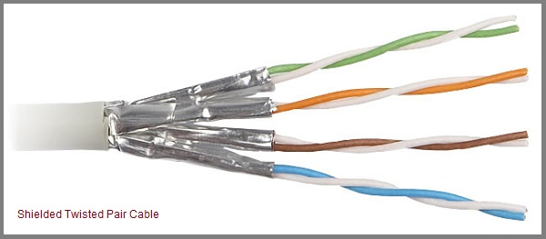
A shielded twisted pair is a cable that contains the mesh surrounding the wire that allows the higher transmission rate.
Characteristics Of Shielded Twisted Pair:
- The cost of the shielded twisted pair cable is not very high and not very low.
- An installation of STP is easy.
- It has higher capacity as compared to unshielded twisted pair cable.
- It has a higher attenuation.
- It is shielded that provides the higher data transmission rate.
Disadvantages
- It is more expensive as compared to UTP and coaxial cable.
- It has a higher attenuation rate.

Coaxial Cable

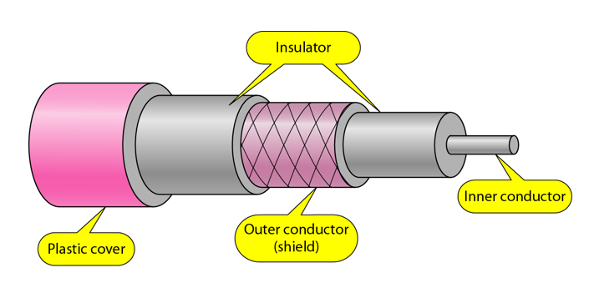

- Coaxial cable is very commonly used transmission media, for example, TV wire is usually a coaxial cable.
- The name of the cable is coaxial as it contains two conductors parallel to each other.
- It has a higher frequency as compared to Twisted pair cable.
- The inner conductor of the coaxial cable is made up of copper, and the outer conductor is made up of copper mesh. The middle core is made up of non-conductive cover that separates the inner conductor from the outer conductor.
- The middle core is responsible for the data transferring whereas the copper mesh prevents from the EMI(Electromagnetic interference).
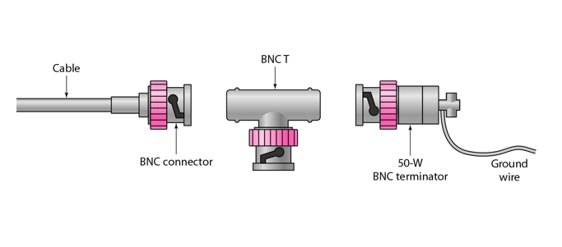
Advantages Of Coaxial cable:
- The data can be transmitted at high speed.
- It has better shielding as compared to twisted pair cable.
- It provides higher bandwidth.
Disadvantages Of Coaxial cable:
- It is more expensive as compared to twisted pair cable.
- If any fault occurs in the cable causes the failure in the entire network.

Fibre Optic
- Fibre optic cable is a cable that uses electrical signals for communication.
- Fibre optic is a cable that holds the optical fibres coated in plastic that are used to send the data by pulses of light.
- The plastic coating protects the optical fibres from heat, cold, electromagnetic interference from other types of wiring.
- Fibre optics provide faster data transmission than copper wires.

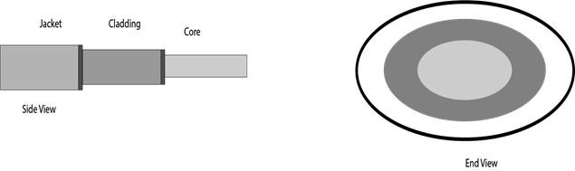

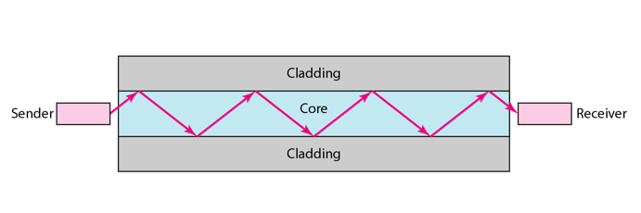

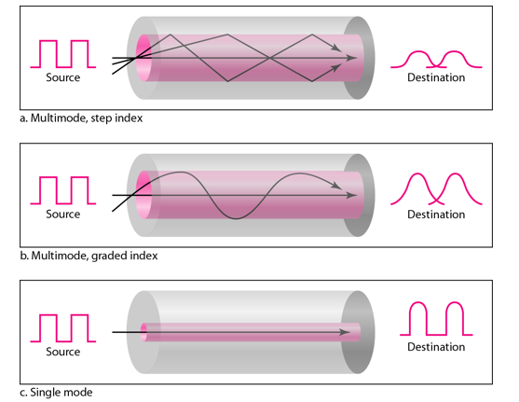
Basic elements of Fibre optic cable:
- Core: The optical fibre consists of a narrow strand of glass or plastic known as a core. A core is a light transmission area of the fibre. The more the area of the core, the more light will be transmitted into the fibre.
- Cladding: The concentric layer of glass is known as cladding. The main functionality of the cladding is to provide the lower refractive index at the core interface as to cause the reflection within the core so that the light waves are transmitted through the fibre.
- Jacket: The protective coating consisting of plastic is known as a jacket. The main purpose of a jacket is to preserve the fibre strength, absorb shock and extra fibre protection.
Following are the advantages of fibre optic cable over copper:
- Greater Bandwidth: The fibre optic cable provides more bandwidth as compared copper. Therefore, the fibre optic carries more data as compared to copper cable.
- Faster speed: Fibre optic cable carries the data in the form of light. This allows the fibre optic cable to carry the signals at a higher speed.
- Longer distances: The fibre optic cable carries the data at a longer distance as compared to copper cable.
- Better reliability: The fibre optic cable is more reliable than the copper cable as it is immune to any temperature changes while it can cause obstruct in the connectivity of copper cable.
- Thinner and Sturdier: Fibre optic cable is thinner and lighter in weight so it can withstand more pull pressure than copper cable.
- 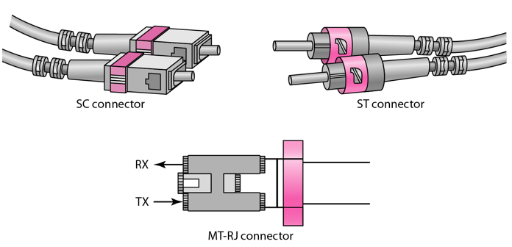

UnGuided Media
Unguided medium transport electromagnetic waves without using a physical conductor. This type of communication is often referred to as wireless communication. Signals are normally broadcast through free space and thus are available to anyone who has a device capable of receiving them.
Unguided signals can travel from the source to the destination in several ways: Gound propagation, Sky propagation and Line-of-sight propagation
- Ground Propagation: In this, radio waves travel through the lowest portion of the atmosphere, hugging the Earth. These low-frequency signals emanate in all directions from the transmitting antenna and follow the curvature of the planet.
- Sky Propagation: In this, higher-frequency radio waves radiate upward into the ionosphere where they are reflected back to Earth. This type of transmission allows for greater distances with lower output power.
- Line-of-sight Propagation: in this type, very high-frequency signals are transmitted in straight lines directly from antenna to antenna.
We can divide wireless transmission into three broad groups:
- Radio waves
- Micro waves
- Infrared waves
Radio Waves:
Electromagnetic waves ranging in frequencies between 3 KHz and 1 GHz are normally called radio waves.
Radio waves are omnidirectional. When an antenna transmits radio waves, they are propagated in all directions. This means that the sending and receiving antennas do not have to be aligned. A sending antenna send waves that can be received by any receiving antenna. The omnidirectional property has disadvantage, too. The radio waves transmitted by one antenna are susceptible to interference by another antenna that may send signal suing the same frequency or band.
Radio waves, particularly with those of low and medium frequencies, can penetrate walls. This characteristic can be both an advantage and a disadvantage. It is an advantage because, an AM radio can receive signals inside a building. It is a disadvantage because we cannot isolate a communication to just inside or outside a building.

Omnidirectional Antenna for Radio Waves
Radio waves use omnidirectional antennas that send out signals in all directions.
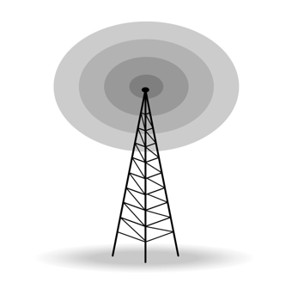

Applications of Radio Waves
- The omnidirectional characteristics of radio waves make them useful for multicasting in which there is one sender but many receivers.
- AM and FM radio, television, maritime radio, cordless phones, and paging are examples of multicasting.

Micro Waves
Electromagnetic waves having frequencies between 1 and 300 GHz are called micro waves. Micro waves are unidirectional. When an antenna transmits microwaves, they can be narrowly focused. This means that the sending and receiving antennas need to be aligned. The unidirectional property has an obvious advantage. A pair of antennas can be aligned without interfering with another pair of aligned antennas.
The following describes some characteristics of microwaves propagation:
- Microwave propagation is line-of-sight. Since the towers with the mounted antennas need to be in direct sight of each other, towers that are far apart need to be very tall.
- Very high-frequency microwaves cannot penetrate walls. This characteristic can be a disadvantage if receivers are inside the buildings.
- The microwave band is relatively wide, almost 299 GHz. Therefore, wider sub-bands can be assigned and a high date rate is possible.
- Use of certain portions of the band requires permission from authorities.

Unidirectional Antenna for Micro Waves
Microwaves need unidirectional antennas that send out signals in one direction. Two types of antennas are used for microwave communications: Parabolic Dish and Horn.
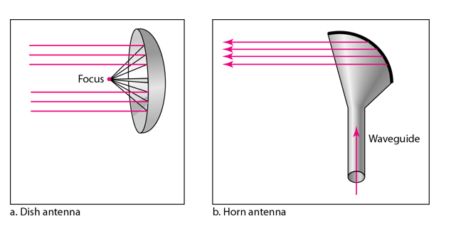
A parabolic antenna works as a funnel, catching a wide range of waves and directing them to a common point. In this way, more of the signal is recovered than would be possible with a single-point receiver.
A horn antenna looks like a gigantic scoop. Outgoing transmissions are broadcast up a stem and deflected outward in a series of narrow parallel beams by the curved head. Received transmissions are collected by the scooped shape of the horn, in a manner similar to the parabolic dish, and are deflected down into the stem.

Applications of Micro Waves
Microwaves, due to their unidirectional properties, are very useful when unicast(one-to-one) communication is needed between the sender and the receiver. They are used in cellular phones, satellite networks and wireless LANs.
There are 2 types of Microwave Transmission :
- Terrestrial Microwave
- Satellite Microwave
Advantages of Microwave Transmission
- Used for long distance telephone communication
- Carries 1000's of voice channels at the same time

Disadvantages of Microwave Transmission
- It is very costly

Terrestrial Microwave
For increasing the distance served by terrestrial microwave, repeaters can be installed with each antenna .The signal received by an antenna can be converted into transmittable form and relayed to next antenna as shown in below figure. It is an example of telephone systems all over the world
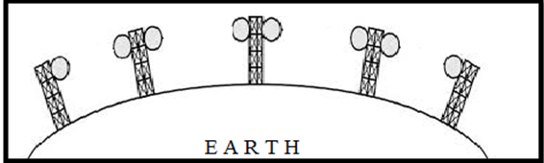
There are two types of antennas used for terrestrial microwave communication :

1. Parabolic Dish Antenna
In this every line parallel to the line of symmetry reflects off the curve at angles in a way that they intersect at a common point called focus. This antenna is based on geometry of parabola.
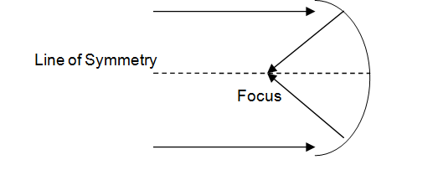

2. Horn Antenna
It is a like gigantic scoop. The outgoing transmissions are broadcast up a stem and deflected outward in a series of narrow parallel beams by curved head.
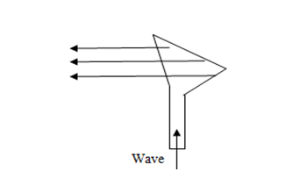

Satellite Microwave
This is a microwave relay station which is placed in outer space. The satellites are launched either by rockets or space shuttles carry them.
These are positioned 36000 Km above the equator with an orbit speed that exactly matches the rotation speed of the earth. As the satellite is positioned in a geo-synchronous orbit, it is stationery relative to earth and always stays over the same point on the ground. This is usually done to allow ground stations to aim antenna at a fixed point in the sky.
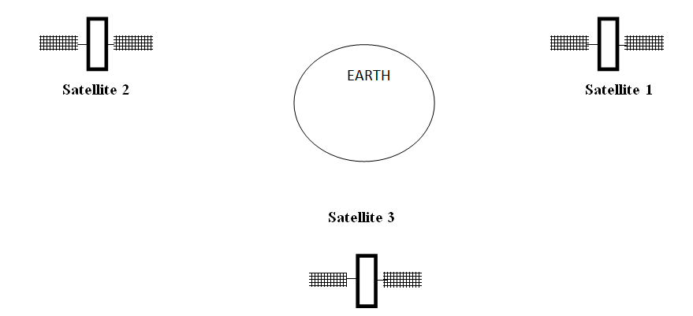

Features of Satellite Microwave
- Bandwidth capacity depends on the frequency used.
- Satellite microwave deployment for orbiting satellite is difficult.

Advantages of Satellite Microwave
- Transmitting station can receive back its own transmission and check whether the satellite has transmitted information correctly.
- A single microwave relay station which is visible from any point.

Disadvantages of Satellite Microwave
- Satellite manufacturing cost is very high
- Cost of launching satellite is very expensive
- Transmission highly depends on whether conditions, it can go down in bad weather

Infrared Waves
Infrared waves, with frequencies from 300 GHz to 400 THz, can be used for short-range communication. Infrared waves, having high frequencies, cannot penetrate walls. This advantageous characteristic prevents interference between one system and another, a short-range communication system in on room cannot be affected by another system in the next room.
When we use infrared remote control, we do not interfere with the use of the remote by our neighbours. However, this same characteristic makes infrared signals useless for long-range communication. In addition, we cannot use infrared waves outside a building because the sun's rays contain infrared waves that can interfere with the communication.

Applications of Infrared Waves
- The infrared band, almost 400 THz, has an excellent potential for data transmission. Such a wide bandwidth can be used to transmit digital data with a very high data rate.
- The Infrared Data Association(IrDA), an association for sponsoring the use of infrared waves, has established standards for using these signals for communication between devices such as keyboards, mouse, PCs and printers.
- Infrared signals can be used for short-range communication in a closed area using line-of-sight propagation.

